Quadrotor Waypoint Tracking with   
Deep Reinforcement Learning

DS551 - Final Project - 2023

Manoj Velmurugan, Swati Shirke, Ramana Kiran, Rigved Sanku

# Problem Statement:

* Objective of this project is to design an RL agent for following waypoints in a simulated quadrotor.
* Here, the current state of the quadrotor will be [position, velocity, orientation, angular rate].
* The agent will learn the task of motion planning and control by interacting with the environment. The agent will give Angular velocities of the 4 rotors and cumulative thrust of the quadrotor as output. These values will be imported in another simulation software to verify if a quadrotor is following waypoints with accuracy.

# Related Work

A team from “University of Zurich” recently demonstrated expert level performance in drone racing with Deep Reinforcement Learning. The drone must pass through a series of windows autonomously solely with onboard sensors and camera.

For more information, please refer to,

Kaufmann, E., Bauersfeld, L., Loquercio, A. et al. Champion-level drone racing using deep reinforcement learning. Nature 620, 982–987 (2023). <https://doi.org/10.1038/s41586-023-06419-4>

In this work, we are going to attempt a simplified version of this problem in simulation. Our scope is limited and more focused on the RL instead of the sensing and hardware implementation aspects!

|  |  |
| --- | --- |
| Their work | Our scope |
| Deep RL using A3C | Deep RL using A3C (or any other method suited for continuous systems) |
| State estimation from sensors and camera | NA Quadrotor’s position and other states are known and fed directly from the environment into agent |
| Window detection from Camera | NA Window locations are known in advance and computer vision is abstracted out |
| Sim2Real and hardware implementation | NA Scope is only simulation |

# Environment and visualization

# 

## Inputs:

1D double vector (23x1) containing,

1. Previous agent outputs - desired angular rates - [wx, wy, wz] – 4x1
2. Position waypoints for next 3 waypoints [x1, y1, x2, y2, x3, y3] – 6x1
3. States of quadrotor – [position, velocity, orientation, angular rate] 13x1

## Output:

1. 1D double vector containing desired angular rates and desired thrust – 4x1
2. Reward. A reward function will be implemented as provided in the referenced paper.

## Termination:

Simulation will be terminated if the drone,

1. Goes below ground level.
2. Reaches last waypoint/goal.

## Environment and Visualization:

We have a Python based quadrotor simulation model built by one of our team members for the “Hands-On Autonomous Aerial Robotics Course” (RBE595).

The simulator has worked robustly for the course. So, we will use the same simulator for this work.

Visualization portions will be stripped out to speed up training.

Trained agents will be visualized on our Blender based visualization utility.

# Agent:

## Agent Class - A3C

# Reward System:

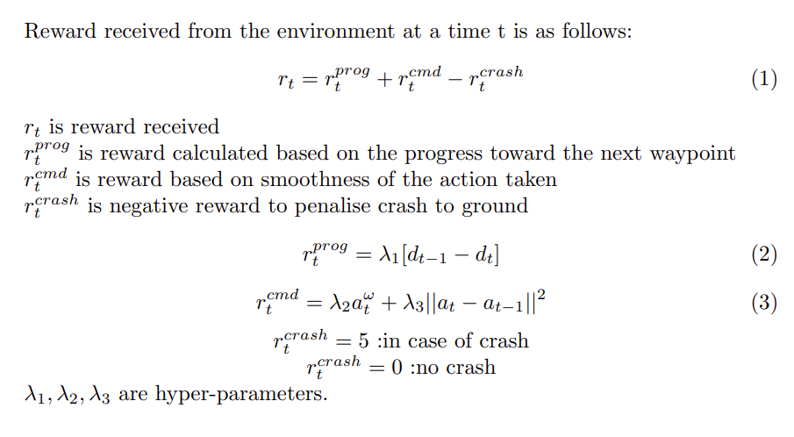

## Network architecture

Idea is to start off with a simple MLP based architecture to fit the which takes in the trajectory inputsand gives out the outputs as mentioned above. In essence this MLP is approximating a controller like Model Predictive Controller (MPC). Based on this performance, we also plan to try out a variant of temporal convolutional networks designed for time series forecasting. The idea of this network is to feed in a set time series inputs to determine the outputs for the current step.

# References

Kaufmann, E., Bauersfeld, L., Loquercio, A. *et al.* Champion-level drone racing using deep reinforcement learning. *Nature* **620**, 982–987 (2023). https://doi.org/10.1038/s41586-023-06419-4